

**Minutes of Trunch Parish Council Meeting**

Held on Tuesday 9th July 2024 at 7pm

Present: Cllr. Richard Miles (Chair), Cllrs. David Burns, David Houlton, Gaynor Houlton, Paul Pearson,Barbara Wilson, Parish Clerk Tracy Neave, two Members of the Public

1. Apologies for absence: Cllr Jeremy Fielding
2. Declarations of interest and requests for dispensations

Cllr Miles: Trunch Village Hall Committee and Allotment Holder, Cllrs Pearson and Wilson Allotment Holders

1. Minutes of previous meeting held on 11th June 2024 were agreed and signed by the Chairman.
2. Public Participation
   1. County Councillor’s report: see appendix 1
   2. District Councillor’s report: nothing to report
   3. Public Participation: A member of the public raised concern over the number of molehills at the playing field. Additional bulbs have been planted to act as a mole deterrent. The council is not able to use mole traps. There was concern regarding the ongoing recent broadband works. The Parish Council received no notification regarding this work. Cllr Miles to contact Cllr Neatherway regarding this and recent lack of notifications from Highways. A prospective tenant/landlord for The Crown Public House had contacted the Council asking for opinions of what the public would want to see at the pub. The Council did not want to respond as they felt they did not have public representation.
3. Correspondence

5.1 NALC weekly updates

5.2 Rural Bulletin

5.3 NALC Chief Executive updates

5.4 Cromer Care Grant information

6. Matters arising from previous minutes

6.1 Neighbourhood Watch: agreed not to set up Neighbourhood Watch in Trunch

7. New items

7.1 Clerk’s report

* Parish Partnership Bid distributed to Councillors: to be discussed in September
* Clerk has completed two qualifications: Certificate in Local Council Administration and Financial Introduction in Local Council Administration
* Clerk attended Agenda/Minutes training. Correspondence was discussed and agreed not to list bulletins/updates.
* Clerk attended Clerk Networking event in June.
* Playing field inspection quotes have been requested
* Grit bin survey for NCC completed
* Playing field inspection to be organised

7.2 It was agreed to hold an educational event on 30th July about climate change and

supporting sustainable health. Cllr Burns to organise event.

7.3 Grants and Funding applications: Ideas for funding must be discussed and agreed by

Council before submitting any applications.

8. Periodic items

8.1 It was agreed to raise Clerk’s salary as per contract of employment in respect of

achieving CILCA qualification to £16.00 per hour.

9. Finance

9.1 Bank statements and bank reconciliation (appendix 2) agreed with statements signed by Cllr Miles.

9.2 Income and Expenditure: see appendix 3

9.3 Payment schedule: agreed with additional payments to Tim Jones grass cutting £1221,

Clerk Salary July £470.17 and Direct Debits to ICO £36.00 and Npower £37.62. See

appendix 4. Cashbook circulated to Parish Councillors for transparency purposes.

9.4 St James Trust annual telephone consultation offered move to improved scheme: To

be discussed at September meeting.

10. Highways

10.1 Highways Inspection Update and Actions: NTR08133 affecting Gunthorpe Lane:

Closure between 8.30 and 15.30 8th July 2024 but may continue until 19th August 2024

10.2 Gullies on Gillingham Road and tree issue awaiting to be cleared.

11. Playing Field

11.1 Cleanup has taken place and new basketball hoop erected, supporting structure

Painted. Tree cutting taken place at playing field.

There is concern over open access to playing field and need to establish who owns

the land.

11.2 Playing field Proposal: Benchs and picnic table to be supported by TVS grant: agreed

Fenced dog area: awaiting quote. Petanque court/planting to be investigated further.

Children’s play area: wobby bridge: to apply for grant. Swings: agreed to replace seats.

Agreed to replace football nets.

12. Planning

13.1 New Planning Application: Nothing to report

13.2 Decisions: Wrights Loke: Deferral

13.3 Appeals: none

13 Footpaths

13.1 Cllr Miles raised the issue of the level of cars being parked on pavements. Cllr Miles to

write to Cllr Neatherway and advice taken on what action can be taken by Council.

14 To receive a report and consider any actions

14.1 Allotments: It has been deemed the hedgerow is the Parish Council’s responsibility.

Diocese confirmed work was undertaken in March 2024 but there is no evidence of this.

Advice to be sought and tree survey to be completed as Diocese will only complete

additional work on areas that are confirmed as unsafe.

14.2 Community Speed: Patrols continue.

14.3 Neighbourhood Plan: nothing to report (training in July)

14.4 Good Neighbour Scheme: Continue to receive and respond to calls.

14.5 Warm Room/Community Café: Work has started on proposal.

15. General Parish Issues

15.1 Bus shelter to be added to asset register. Inspection of assets needs to be set up and

Recorded.

15.2 Defibrillator: suggested that does the village require a further defibrillator and could

a training event be set up

16. Date of next meeting 10th September 2024

Meeting closed at 20.23pm

Appendix 1

**County Councillor report**

**July 2024**

Right, well, back to work then.

It’s obviously far too early to tell the impact of a change in government – and the Prime Minister has made it clear that change will happen slowly. But three things are already clear: the Government hasn’t changed the name of the Department in charge of local government so the ‘Levelling Up’ focus stays; that agenda sits with the Deputy Prime Minister and she doesn’t strike me as the sort of person who is going to sit staring out of the window and doing nothing for five years; there are more people in Parliament and in government with Local Government backgrounds. I only have one hope – that all of this means that they are more willing to give you, as local residents, more say over issues that affect our communities. We’ll see!

**Parish Partnership Scheme**

You will have received the letter from the County Council inviting you to bid for the Parish Partnership scheme. I just wanted to pick out the enhanced support for smaller Parishes which is worth looking at if you qualify. Bids can be combined with funding from the Local Member Highways Fund (‘my’ pot of money) which I usually allocate on a first come first served basis – so if you have something in mind, please let me know. And note, too, that the PP scheme cannot fund TROs.

**Changes to Highways personnel**

You’ll probably already be aware that local Highways Officer, Steve White, has moved on to a new role and his replacement is Chris Purvis. There’s also new Area Manager – Damien Jeffries – so Damien will be Chris’ boss. Your Clerk will be well used to working with the local Highways team but if I can help deal with any issues that come up, just let me know.

**Roadside Nature Reserves**

Last week I got an email telling me that a new Roadside Nature Reserve had been set up in Bradfield. I have to admit I wasn’t aware of their existence but they seem to be a long-running scheme between the County Council and Norfolk Wildlife Trust. If you are interested in finding out more, you can read about them here, the page includes an interactive map showing the locations of the reserves: <https://www.norfolk.gov.uk/article/57402/Norfolks-Roadside-Nature-Reserves>

**County Council Reserves**

Reserves of a different nature this time. I was asked at a Parish Council recently about the County Council’s approach to managing its financial reserves. I thought I would share the response in case you are interested:

The County Council holds provisions, reserves, and general balances in order to ensure that it can meet unforeseen or uncertain expenditure, and to meet specific future commitments as they fall due. The level of provisions and reserves are continually reviewed to ensure that the amounts held are within reasonable limits, which are consistent with the council’s risk profile, but also ensure that council taxpayers’ funds are not held unnecessarily.

The Council’s reserves consist of the following main categories:

* Earmarked Reserves (broadly reserves which are held for a specific / special purpose, or to fund expenditure that has been delayed).
* Local Management of Schools (LMS) reserve (balances belonging to individual schools).
* Dedicated Schools Grant (DSG) reserve (the cumulative deficit position of the ringfenced DSG funding provided by the DfE. Since 2018-19, DSG has been reported as a separate ring-fenced reserve).
* General balances (Reserves that are not earmarked for a specific purpose – held to enable the County Council to manage unplanned or unforeseen events. The Director of Strategic Finance is required to form a judgment on the level of this reserve and to advise Cabinet and County Council annually).

Wherever possible, the Council seeks to make contributions into reserves as part of closing the accounts each year. The latest position of the Council’s reserves and provisions can be found in the outturn report to Cabinet here: [Document.ashx (cmis.uk.com)](https://eur02.safelinks.protection.outlook.com/?url=https%3A%2F%2Fnorfolkcc.cmis.uk.com%2Fnorfolkcc%2FDocument.ashx%3FczJKcaeAi5tUFL1DTL2UE4zNRBcoShgo%3DSUy1wZXee9DhpOZEcFl%252bE9qx109gYAUT23CjRFInx2wCHKt%252bcfHM%252fQ%253d%253d%26rUzwRPf%252bZ3zd4E7Ikn8Lyw%253d%253d%3DpwRE6AGJFLDNlh225F5QMaQWCtPHwdhUfCZ%252fLUQzgA2uL5jNRG4jdQ%253d%253d%26mCTIbCubSFfXsDGW9IXnlg%253d%253d%3DhFflUdN3100%253d%26kCx1AnS9%252fpWZQ40DXFvdEw%253d%253d%3DhFflUdN3100%253d%26uJovDxwdjMPoYv%252bAJvYtyA%253d%253d%3DctNJFf55vVA%253d%26FgPlIEJYlotS%252bYGoBi5olA%253d%253d%3DNHdURQburHA%253d%26d9Qjj0ag1Pd993jsyOJqFvmyB7X0CSQK%3DctNJFf55vVA%253d%26WGewmoAfeNR9xqBux0r1Q8Za60lavYmz%3DctNJFf55vVA%253d%26WGewmoAfeNQ16B2MHuCpMRKZMwaG1PaO%3DctNJFf55vVA%253d&data=05%7C02%7Cedward.maxfield.cllr%40norfolk.gov.uk%7C5f9a61959951477851a008dc81553d93%7C1419177e57e04f0faff0fd61b549d10e%7C0%7C0%7C638527450312497178%7CUnknown%7CTWFpbGZsb3d8eyJWIjoiMC4wLjAwMDAiLCJQIjoiV2luMzIiLCJBTiI6Ik1haWwiLCJXVCI6Mn0%3D%7C0%7C%7C%7C&sdata=eIZ3XG6xK3cLmtoBaNXCR0dsEhFzmXJ2HDPKKw4HYu0%3D&reserved=0) (see page 79 onwards). As at 31/03/2024, the Council’s general fund was £25.486m and reserves and provisions (including LMS but excluding DSG) were £172.636m.

The County Council’s full reserves policy is set out annually as part of budget-setting here: [Document.ashx (cmis.uk.com)](https://eur02.safelinks.protection.outlook.com/?url=https%3A%2F%2Fnorfolkcc.cmis.uk.com%2Fnorfolkcc%2FDocument.ashx%3FczJKcaeAi5tUFL1DTL2UE4zNRBcoShgo%3DPYBEApk6w4emAltysmdtNr4XlVojPgnQmIiX%252b%252fsd%252fsMlBN%252bAUEthag%253d%253d%26rUzwRPf%252bZ3zd4E7Ikn8Lyw%253d%253d%3DpwRE6AGJFLDNlh225F5QMaQWCtPHwdhUfCZ%252fLUQzgA2uL5jNRG4jdQ%253d%253d%26mCTIbCubSFfXsDGW9IXnlg%253d%253d%3DhFflUdN3100%253d%26kCx1AnS9%252fpWZQ40DXFvdEw%253d%253d%3DhFflUdN3100%253d%26uJovDxwdjMPoYv%252bAJvYtyA%253d%253d%3DctNJFf55vVA%253d%26FgPlIEJYlotS%252bYGoBi5olA%253d%253d%3DNHdURQburHA%253d%26d9Qjj0ag1Pd993jsyOJqFvmyB7X0CSQK%3DctNJFf55vVA%253d%26WGewmoAfeNR9xqBux0r1Q8Za60lavYmz%3DctNJFf55vVA%253d%26WGewmoAfeNQ16B2MHuCpMRKZMwaG1PaO%3DctNJFf55vVA%253d&data=05%7C02%7Cedward.maxfield.cllr%40norfolk.gov.uk%7C5f9a61959951477851a008dc81553d93%7C1419177e57e04f0faff0fd61b549d10e%7C0%7C0%7C638527450312510775%7CUnknown%7CTWFpbGZsb3d8eyJWIjoiMC4wLjAwMDAiLCJQIjoiV2luMzIiLCJBTiI6Ik1haWwiLCJXVCI6Mn0%3D%7C0%7C%7C%7C&sdata=ixSu1jIIGgQfd8zg5EE5JWpfqbxcdmtNUK2GleT5a0g%3D&reserved=0) (see in particular page 226 onwards).

**Buses**

The County Council is now funding an increased frequency of service on the Norwich – Cromer and Sheringham Route X44 and a later bus back from Norwich on the X55 service at 22:40 to allow a way back to North Walsham after evenings out in the city. This is thanks to extra money from the government to support bus services.

**Norfolk Marathon**

I was asked recently about the road closure process for the Norfolk Marathon. I thought you might find the reply I received from Highways useful:

All local parish councils were contacted and the proposals discussed with them prior to the Norfolk Marathon. The Marathon was discussed at the Norfolk Safety Advisors Group in length, all business affected by the route were consulted, Advance warning boards detailing the road closures were erected on site 10 days prior to the event, and all property frontages on the route, were letter dropped detailing the event.

**Cuts to SEND support**

You might have seen press reports about cuts to funding for schools to support those with disabilities and additional needs. This is a response to the failure of the County Council’s plans to reduce demand for support in schools by working with families earlier. This scheme is called Norfolk First Inclusion or the ‘Safety Valve’ that was supposed to unlock extra government funding. I’m aiming to find out more about the likely future of the scheme and the impact on SEND funding and will share the information when I have it.

**And finally**

To return to the General Election. As an Independent councillor, I have deliberately stayed out of the political fight over the last few weeks. I do, though, want to take this opportunity to record my thanks to Duncan Baker for his hard work and dedication to tackling local issues. I found him very responsive and helpful on any matter that was taken to him.

Ed Maxfield

[www.edmaxfield.org.uk](http://www.edmaxfield.org.uk)

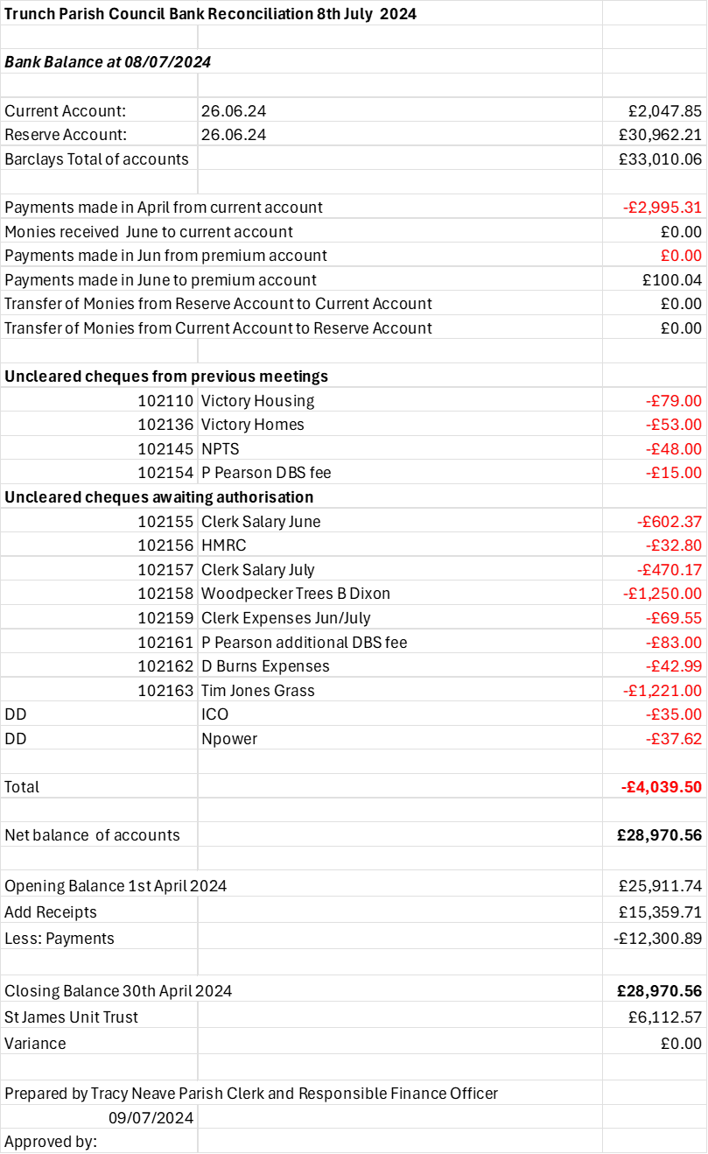

Appendix 2



Appendix 3

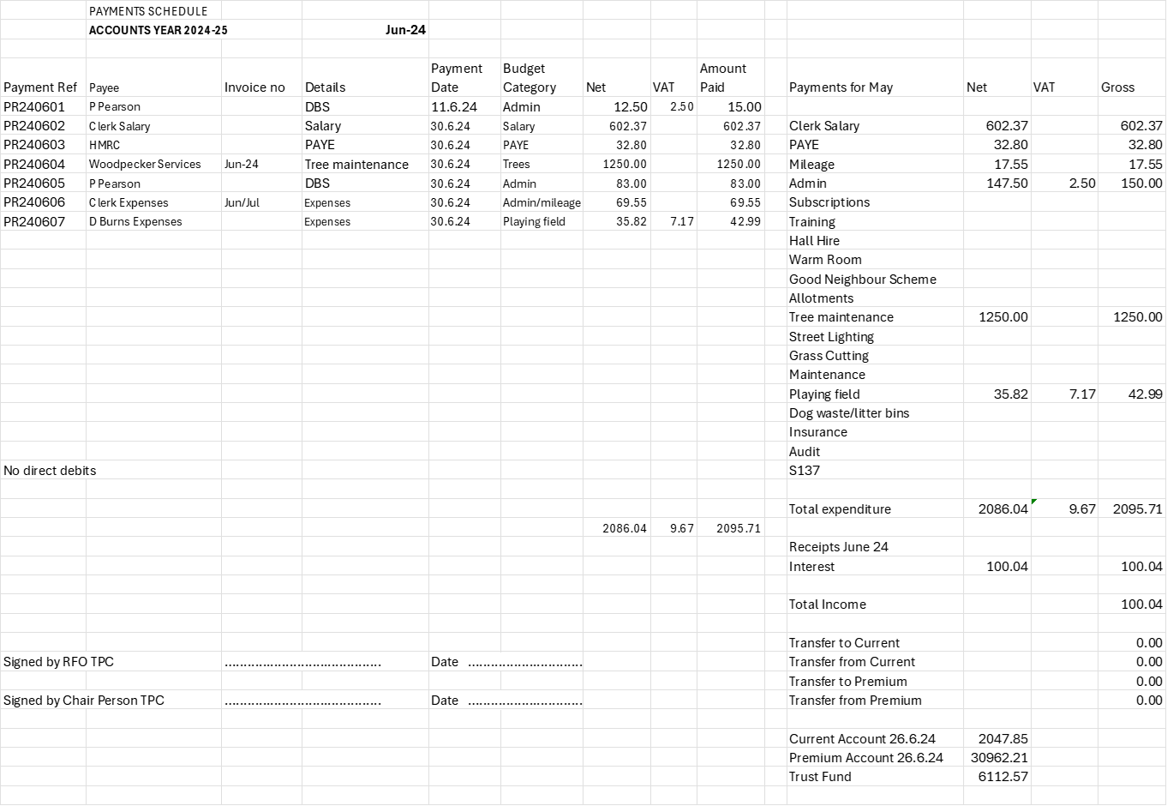

Appendix 4