

**Minutes of Trunch Parish Council Meeting**

Held on Tuesday 8th October at 7pm

Present: Cllr. Gaynor Houlton (Chair), Cllrs. David Burns, Malcolm Bulley Jeremy Fielding, Barbara Wilson, Peter Neatherway, Ed Maxfield, Parish Clerk Tracy Neave, nine Members of the Public

1. Apologies for absence: Cllr David Houlton, Richard Miles, Paul Pearson
2. Declarations of interest and requests for dispensations

Cllr Wilson: Allotment Holder

1. Minutes of previous meeting held on 10th September 2024 were agreed and signed by Cllr Burns.
2. Public Participation
   1. Simon Biddulph Representative County Broad Band did not attend
   2. County Councillor’s report: see appendix 1 Cllrs Maxfield and Neatherway are meeting with Highways to discuss current issues.
   3. District Councillor’s report: Disappointed as per all those attending that there was no representation from County Broadband. Cllr Neatherway will help parishioners and Council with objections regarding Wrights Loke.
   4. Public Participation: A member of the public was disappointed with the Parish Council response to the Wrights Loke planning application: Clerk to write letter to Planning Committee. A member of the public said he had mixed feedback regarding the County Broadband work.
   5. Cllr Wendy Fredericks Deputy Leader of North Norfolk District Council Social Housing, Portfolio Holder for Housing and Peoples’ Services attended the meeting and took questions. There is an Empty Homes Officer, currently 1% of all houses in North Norfolk area. From next April, second homeowners will be charged double council tax.
3. Correspondence

5.1 Age Friendly North Norfolk District Council Partnership: Cllr Miles would like to investigate this.

5.2 Trunch Village Society will consider the grant request from the Parish Council in their new

financial year. This should be considered in December.

5.3 The grant application to the Cooperative Society in respect of the pétanque court was not

successful. Cllr Burns will source alternative grant applications.

1. Matters arising from previous minutes
   1. Review of Projects meeting: The meeting was held to discuss and prioritise projects and workload for the next year in readiness for the preparation of the budget. It was agreed that the Community Café project would not go ahead. Cllrs Bulley and Burns had met with a local shopkeeper to discuss provision of a small-scale delivery service. Further investigation to be undertaken.

7. New items

7.1 Parish Partnership Scheme: application for trod-path has been started. Cllr Burns to help Clerk.

8. Periodic items

8.1 Request from Trunch Village Hall for the Parish Council to be responsible for grounds

maintenance as currently undertaken by volunteers. Clerk to obtain costs and present at next

meeting.

9. Finance

9.1 Bank statements and bank reconciliation (appendix 2) agreed with statements signed by Cllr

Gaynor Houlton

9.2 Income and Expenditure: see appendix 3

9.3 Payment schedule: see appendix 4

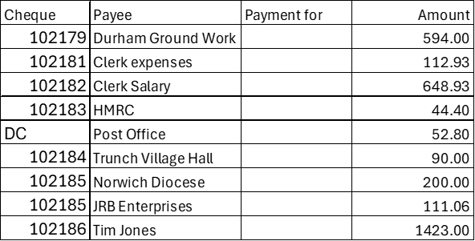

Late payment Cllr Burns Expenses £60

9.4 St James Trust nothing to report

9.5 Budget preparation document circulated to Councillors. Discussion to follow

10.Highways

10.1 Highways Inspection Update and Actions: new page set up on website to show Highways

Updates.

10.2 A blockage at the Social Club has been identified and work has been scheduled.

11. Playing Field

11.1 Contractor has suggested to additional cuts due to the grass still growing. Clerk to obtain quotes.

12. Planning

12.1 New Planning Application: Planning Application PF/24/1776 Warren Farm: Objection

12.2 Decisions: PF/24/1729 2 Wades Close Trunch: approved

12.3 Appeals: nothing to report

13 Footpaths: dog fouling especially at the recreation ground has increased

14. To receive a report and consider any actions

14.1 Allotments: It was agreed to hire a skip for £225.60. Thanks were given for the donated green

house. Invoices are being sent out for due rentals.

14.2 Community Speed: General improvement in decreased speeding.

14.3 Neighbourhood Plan: Article sent for publication in Mardle.

14.4 Good Neighbour Scheme: Additional volunteers required.

14.5 Warm Room: to commence in December one day a week from 12.30pm to 3.30pm.

15. General Parish Issues

15.1 Charging for recycling: consider inviting service representative

15.2 Environmental Group: request for volunteers.

Neighbour Scheme

16. Date of next meeting 12th November 2024

Meeting closed at 7.50pm

Appendix 1:

**County Councillor’s report October 2024**

Reporting Highways issues

*With the bad weather arriving, I asked the Highways team to remind us of the best way to report emergencies such as trees down blocking roads. Please share this information:*

The best way to report emergency issues is to call 0344 800 8020, the call centre will then direct the emergency to a member of my team, failing that(days like today when were all away from desks) they will transfer it to a capable member of the greater North Area team. There is always standing cover for all areas within North area.

County Broadband

I’m aware of a number of reports of problems with County Broadband’s efforts to ‘make good’ where they have installed cabling. I have asked Highways to review this at a senior level and to demand improvements from the company

Norfolk’s work on tackling drug and alcohol misuse highlighted in a national report

*The following is from the County Council’s press release. If anyone has any comments about Norfolk’s approach in practice, I’d be happy to hear it and to pass comments on.*

Work done in Norfolk to tackle substance misuse has been highlighted in a national report by the Local Government Association (LGA).

The report titled [‘From Harm to Hope: A 10-year drugs plan to cut crime and save lives’](https://www.local.gov.uk/publications/two-years-progress-review-harm-hope-10-year-drugs-plan-cut-crime-and-save-lives#introduction), features positive examples of support for vulnerable people.

The report shines a light on the work of the Norfolk Drug and Alcohol Partnership (NDAP) to tackle drug and alcohol related deaths and support people with substance misuse issues. [The report underscores the efforts of different bodies in Norfolk](https://www.local.gov.uk/case-studies/10-year-drug-strategy-norfolk-county-council) to share information to combat the harm caused by new synthetic opioids, and the work the police do to shut down supply chains.

Flourish Awards

Congratulations to the people and organisations that won Flourish Awards this year. The Flourish Award programme is organised by the County Council and celebrates work involving children and young people. This year, the Flourish Awards received more than 400 nominations for 222 different people, teams or projects, drawn from Voluntary Community and Social Enterprises (VCSE) organisations and groups, schools, statutory organisations including health, education, criminal justice and local authorities, and local businesses.

If you know anyone who works with children and young people, please make sure they are aware of the Flourish Award programme for next year!

Recycling centres

*I was impressed by the cheek of the County Council dressing this up as an ‘improved customer experience’ for anyone using recycling centres. Quite how it improves the experience compared to just being able to turn up to drop stuff off when you need to, is beyond me but I share this for information:*

Anyone wishing to visit a Norfolk recycling centre from Monday 18 November 2024, must book in advance.  Bookings can be made up to seven days ahead either online via the council’s website or by phoning the customer service centre. The new booking system will be live from Monday 11 November.

Slots are available every fifteen minutes and people can make a booking or cancel one right up until the time of the booking. People will be asked to give the registration number of the vehicle they will be using on the day. Business and trade waste customers will also be asked to provide their waste carriers licence number.

Everyone has to book to drop off waste at the recycling centre, including those arriving on foot or by bicycle. People do not have to book if they only want to visit the Re-use Shop but if they also want to leave waste in the same visit, then they need to book ahead.

It’s budget setting time again

*The County Council is having to face up to the latest round of cuts. This is an edited version of what they are saying about it.*

The Council’s budget is expected to grow by £64.5 million for 2025-26 , however this is not expected to cover the projected increases in demand, particularly in adult social care and children’s services.

Cabinet members will consider a number of budget proposals when they meet on Monday 7 October. The council faces 'a significant challenge’ in developing Norfolk’s 2025-26 spending plan that seeks to address a budget gap of £44.75 million.

Further council-wide financial controls will be considered in 2024/25 if financial pressures are not adequately addressed through departmental controls. These ‘enhanced financial controls’ would increase centralised financial monitoring and place a freeze on some non-essential expenditure. So far they have ‘identified’ savings of:

• Adult social services, £16.52 million

• Children’s services, £7 million

• Communities and environment, £0.613 million

• Infrastructure, £6.082 million

• Fire and rescue, £0.065 million

• Strategy and transformation, £1.67 million

• Chief executive’s directorate, £0.102 million

• Finance, £1.5 million

Proposals that would go out to public consultation are:

• Raising council tax – with the following options: an increase of 3%, an increase of up to 5%, an increase of more than 5%.

• Review of our Housing Related Support Services

• Switch off a further 2% of Norfolk County Council maintained streetlights

Norfolk Offshore Wind Zone

|  |
| --- |
| You have probably received this as Parish Councillors but sharing in case it is useful:  **Launch of Norfolk Offshore Wind Zone Community Fund**  We are very pleased to announce the launch the Discovery Phase of Norfolk Offshore Wind Zone's Community Fund. The Norfolk Zone fund will support communities across rural Norfolk to help create places where people want to live and thrive, now and in the future. Our team at RWE will be working with Norfolk Community Foundation to deliver exciting funding opportunities for local initiatives driven by those who know their communities best.  [**Read more about the Community Fund**](https://eur02.safelinks.protection.outlook.com/?url=https%3A%2F%2F4u04s.r.a.d.sendibm1.com%2Fmk%2Fcl%2Ff%2Fsh%2FSMK1E8tHeG13ExGNhKzHyk8b8zRa%2F861P2LEPkRLZ&data=05%7C02%7Cedward.maxfield.cllr%40norfolk.gov.uk%7Cc0ba7eda075e4676f98508dcdef21968%7C1419177e57e04f0faff0fd61b549d10e%7C0%7C0%7C638630378610026224%7CUnknown%7CTWFpbGZsb3d8eyJWIjoiMC4wLjAwMDAiLCJQIjoiV2luMzIiLCJBTiI6Ik1haWwiLCJXVCI6Mn0%3D%7C0%7C%7C%7C&sdata=SjaxUckJ0IR7lDlw3TNuQ4CoNTeuHY912mckH9NqNOU%3D&reserved=0)    **What is the Discovery Phase?**  The Discovery Phase is an initial funding round through which fund administrators Norfolk Community Foundation and RWE will seek to build an understanding of the specific needs of the communities living nearest to the onshore infrastructure of the wind farm projects.  This 1 year Discovery Phase will offer grants of up to £10,000 from an initial pot of £100,000.  [**Read more about applying for funding and Discovery Phase eligibility criteria**](https://eur02.safelinks.protection.outlook.com/?url=https%3A%2F%2F4u04s.r.a.d.sendibm1.com%2Fmk%2Fcl%2Ff%2Fsh%2FSMK1E8tHeG7uh65KsV8m4ZRL7I1q%2F6R0qf4XFGc6d&data=05%7C02%7Cedward.maxfield.cllr%40norfolk.gov.uk%7Cc0ba7eda075e4676f98508dcdef21968%7C1419177e57e04f0faff0fd61b549d10e%7C0%7C0%7C638630378610043661%7CUnknown%7CTWFpbGZsb3d8eyJWIjoiMC4wLjAwMDAiLCJQIjoiV2luMzIiLCJBTiI6Ik1haWwiLCJXVCI6Mn0%3D%7C0%7C%7C%7C&sdata=Ar71JDl5dnr5wn%2BnTB1uUfV2oslE4I4jlv6S7p8DlMA%3D&reserved=0)**.**    **We're also looking for people who would like to be on the Community Fund Panel - could that be you?**  Every stage of the fund development has involved collaboration with local communities – from identifying community priority areas to deciding how funds will be allocated - and we want this to continue through the operational phase of the Community Fund. We are inviting local people to join the Norfolk Offshore Wind Zone Community Panel to help further develop the fund’s strategy and to make decisions on which projects are funded.  [**Read more about decision-making and the process for applying to be on the Panel**](https://eur02.safelinks.protection.outlook.com/?url=https%3A%2F%2F4u04s.r.a.d.sendibm1.com%2Fmk%2Fcl%2Ff%2Fsh%2FSMK1E8tHeGEm9EuI3fIGAOk55ac6%2F2t0xl6Z2_RBF&data=05%7C02%7Cedward.maxfield.cllr%40norfolk.gov.uk%7Cc0ba7eda075e4676f98508dcdef21968%7C1419177e57e04f0faff0fd61b549d10e%7C0%7C0%7C638630378610057690%7CUnknown%7CTWFpbGZsb3d8eyJWIjoiMC4wLjAwMDAiLCJQIjoiV2luMzIiLCJBTiI6Ik1haWwiLCJXVCI6Mn0%3D%7C0%7C%7C%7C&sdata=uR4vr8pYz9Zweu4b%2FSzSfMGPr%2BF334iP%2FkSIL8d03qw%3D&reserved=0) |

Ed Maxfield

Appendix 2



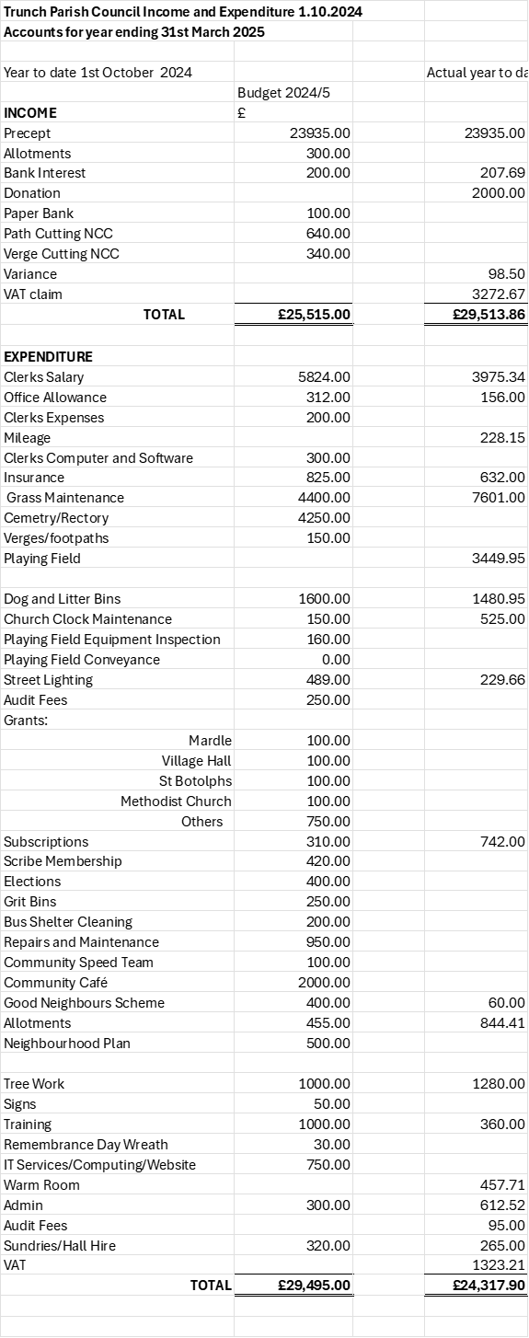

Appendix 3

