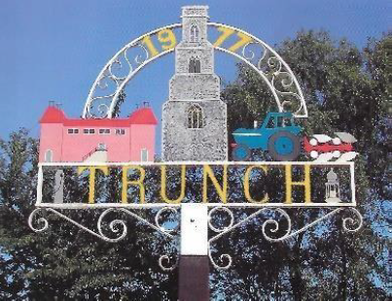

**TRUNCH PARISH COUNCIL MEETING**

**TO BE HELD ON TUESDAY 8th April 2025 AT 7PM IN TRUNCH VILLAGE HALL, KNAPTON ROAD, TRUNCH, NR28 0QE**

Councillors are summoned to, and members of the public and press are invited to attend. At item 5 the public will be invited to give their views and questions to the Parish Council on issues on the agenda or raise issues for the consideration of inclusion at future meetings. This item will generally be limited to a 30-minute duration and will first include County/District Councillors and Police reports.

*Tracy Neave Clerk to Trunch Parish Council 3rd April 2025*

**AGENDA**

1. Apologies for absence
2. To receive declarations of interest for items on the agenda and to consider any requests for dispensations:

4. To confirm the Minutes of the meeting held on Tuesday 11th March 2025

5. Public Participation

5.1 County Councillor,s report sent via email

5.2 District Councillor’s report

5.3 Public Participation

6 Correspondence

6.1 Email North Norfolk District Council Gambling Regulations consultation

6.2 Norfolk Association Local Councils Board Member Nomination Paper

6.3 Proposals for Local Government reorganisation

8. Matters arising from previous minutes

8.1 S106 monies

8.2 Land ownership along footpath FP5

9. Request for defibrillator training Village Hall

10. Finance

10.1 Bank statements and bank reconciliation

10.2 Income and Expenditure

10.3 Payment schedule: (Other late payments may be authorised)



Late payments:

NALC Subscription £262.31

Victory Homes £24

Patrick Robinson Allotment Clearance £299.89

10.4 Notification of Clerk’s incremental increase as per contract

10.5 Clerks request to decrease hours

10.6 Insurance policy renewal

10.7 Year end VAT return submitted £281.88

11. Highways

11.1 NRTO9449 Gimingham Road closure 13th to 15th May 2025

11.2 NRTO9451 Knapton Road closure 12th May 2025

11.3 Reminder of Marathon

12. Playing Field

12.1 To receive any playing field matters and agree actions

12.2 Update on playing field – inspection rota and work from inspection report

13. Planning

13.1 New Planning Application: PF/25/0315 Itarsi Chapel Road Trunch objection

13.2 Decisions:

13.3 Appeals:

13.4 Replacing J Fielding on planning group

14. Footpaths

14.1 To receive footpath matters and agree action

15 To receive a report and consider any actions

15.1 Allotments.

15.2 Community Speed

15.3 Neighbourhood Plan

15.4 Good Neighbour Scheme

15.5 Warm Room

15.6 Environmental Group

16. General Parish Issues (for information only)

17. Date of next meeting: 13th May 2025 including Annual Parish Meeting