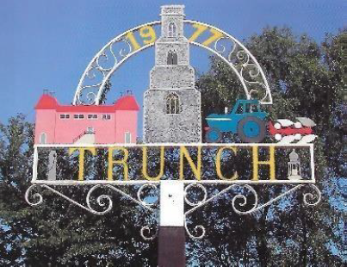

Trunch Annual Parish Meeting

To be held on Tuesday 13th May 2025
at 7pm at the Village Hall Trunch

The meeting is open to the public and all electors
are invited to attend.

Agenda
- Apologies of absence
- Approval of the minutes of the previous Annual Parish Meeting held on 6th May 2024
- Parish Council Chairperson’s report
- Parish Council Financial report
- District and County Councillors report
- Reports from the community groups
- Open forum for questions from the public
- Date and time of next meeting to be advised

