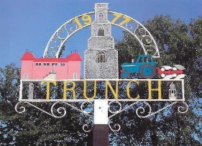

Minutes of Trunch Parish Council Meeting

Held on Tuesday 11th February at 7pm

Present: Cllrs Gaynor Houlton, (Chair), David Burns, Malcolm Bulley Jeremy Fielding, Barbara Wilson, David Houlton, Paul Pearson, Ed Maxfield, Four Members of the Public, Parish Clerk Tracy Neave

- Apologies for absence: Cllr Paul Pearson; Peter Neatherway

- Declarations of interest and requests for dispensations
Cllr Wilson: Allotment Holder; Cllr.Pearson allotment holder

- Minutes of previous meeting held on 14th January2025 were agreed and signed by the Chairperson.

- Public Participation
  - County Councillor’s report: see appendix 1. Cllr Maxfield reported that the planned elections for 2025 have been cancelled due to the Governments plans for devolution. The Western Link application has been withdrawn with a question of how much money the County Council will receive back from the Government, if any.
  - District Councillor’s report: Cllr. Neatherway had advised there would be a meeting on 11th February to discuss the parking issues on Cornish Avenue. It is hoped the Planning Officer will attend the next meeting.
  - Public Participation: A member of the public expressed concern about the poor state of the playing field regarding the
Molehills and the mud around the foothpath. He also queried the value of the final return from St James Trust. The Clerk explained that monies had been removed from the Trust in previous times, so there had been a healthy return from the initial investment. A Member of the Public expressed concern over Planning Application AP/24/0012 (The Roost) saying that he felt the Parish Council had acted in an unlawful manner in how the objection had been raised and was disappointed that the applicants had not supported the application. He also felt there was conflict over affordable housing. See agenda item 12.3

- Correspondence:
  - NALC voting paper: it was agreed to vote for the special resolution for NALC to be a company limited by guarantee.
  - Roadside nature reserve notification Brick Kiln Lane
  - North Norfolk District Council Accountancy second home change to tax base
  - NALC introductory letter New County Officer
- Matters arising from previous minutes
  - Chris Purvis NNDC advised that the idea of a trodpath along the North Walsham Road is not feasible. Cllr Maxifield to discuss the idea of an implied path as an alternative.
  - The Clerk confirmed that the Council have resigned as Trustees of MADRA.

7. New Items
7.1 Trunch FP5 and Southrepps BR11 creation of connecting right of way. After receiving advice from NNDC, Clerk to
Investigate who owns the land and contact the landowner.

8. Periodic items
8.1 Tender for grass cutting: This has been awarded to Tim Jones from 2025 to 2028 at a value of £7644 per annum.

9. Finance
9.1 Bank statements and bank reconciliation agreed with statements signed by Cllr Gaynor Houlton. See appendix 2
9.2 Income and Expenditure: see appendix 3
9.3 Payment schedule:

Cheque | Payee | Payment for | Amount
102208 | Clerk | Salary Jan 25 | 673.08
102209 | HMRC | PAYE | 50.40
102210 | D Burns | Expenses | 44.89
102211 | Trunch Village Hall | Room Hire | 90.00
102212 | Victory Homes | Warm Room | £69.00
102213 | Clerk Expenses | Various | £61.53

One late payment: Victory Housing £65.00

9.4 St James Trust account closed: Funds received £6299.30
9.5 Unity Banking: It was agreed to remain with Barclays as they have the facilities for dual authorised BACS payments.
Cllrs Miles and Burns are set up to authorise payments, Cllrs Gaynor Houlton and Fielding to complete authorisation
Process.

10. Highways
10.1 NTRO9050 Gimingham to facilitate Anglian Water sewer repairs
10.2 The decayed tree on Gimmingham Road has been removed. Cllrs to advice Clerk of potholes around the village
and these will be reported to Highways.

11. Playing Field
11.1 The Playing Field working party reviewed the inspection report and will create a priority list for maintenance. There
is concern of the amount of work noted in the report along with the expense, liability and health and safety factors. It
was felt that some of the work may have to be undertaken by external contractors and that some of the equipment
may have to be closed off until the work is completed.

12. Planning
12.1 Planning Application – nothing to report
12.2 Decisions – nothing to report
12.3 Appeals: AP/24/0012 Construction of two-bed roomed detached dwelling, cartshed
Garage and associated works The Roost Mundesley Road Trunch NR29 0QB: appeal dismissed
.

13 Footpaths:
13.1 There are reports of rook scarers frightening some children and dogs.

14. To receive a report and consider any actions
14.1 Allotments: There are no outstanding payments. New agreements and letters being sent out advising of rent
increase. Allotment inspection to be undertaken soon. There are still vacant plots.
14.2 Community Speed: nothing to report
14.3 Neighbourhood Plan: nothing to report
14.4 Good Neighbour Scheme: relatively quiet with one new volunteer.
14.5 Warm Room: Food inspection achieved 5 star rating. Warm room ends first week in March 2025. Review to be held
in summer with public consultation to ascertain whether to continue next winter.
14.6 Snappy Shopper: To be promoted on website and Mardle. Agreed to remove as monthly agenda item.

15. General Parish Issues
- There is a potential co-option of a parish councillor as a parishioner is keen to join the Council
- The Environment Group are working on setting up an environmental day. The Council have been advised that there is £609.91 S106 monies available from NNDC which could be available for potential funding for environmental/outdoor projects.
- There will be a class using the Village Hall on Tuesdays is not accessible until 6.45pm

16. Date of next meeting 11th March 7pm at Trunch Village Hall

Public meeting closed at 7.55pm

Appendix 1

County Councillor’s Report
February 2025
Recycling
Following on from my report last month about fly tipping, I have asked Norfolk County Council’s Scrutiny Committee to examine the performance of the Council’s waste and recycling service. Particularly with reference to the impact of the new booking system, the charges that are imposed and the closures and reduced hours. Hopefully we will receive a report on that soon.
I also asked for an update on plans for North Walsham Recycling Centre as a couple of years ago there were plans to move it to a new location so that they could improve the re-use facilities there. This is reply I received:
Plans for a new North Walsham Recycling Centre remain within our infrastructure programme and the project is in the early stages. We have carried out some initial land searches and pursued a couple of options, which have so far been ruled out.
Waste Services Infrastructure programme is addressed as part of the Cabinet paper published later today, which through the Monitoring Report covers the Council’s financial strategy for capital. We are continuing to consider land options, even though there is currently no fixed programme to deliver the North Walsham recycling centre. Finding suitable land can be challenging so time scale of delivery will, in part be guided by when we find an appropriate site.
So, in short, I don’t have any further progress to share with you at this point but can let you know that it remaining part of our Infrastructure development plans.
Devolution
Well, we were supposed to know by now what was happening with devolution and the County Council elections. It seems like we need to wait another week or so before we get an indication from the Government whether Norfolk has been accepted on to the devolution programme and whether the elections scheduled for May will be postponed.
Norfolk County Council met on 9th Jan and voted overwhelmingly to apply to join the devolution programme. This is part of what I said in the debate:
My view is that the devolution deal has the chance to bring transformative change to the region. If we see it as the start of a journey and not the end point. Which is a point I made when we debated the last proposal. If we get on the bus we can drive local government – and the region in a new direction. But it will need determined leadership with a clear vision.
We need to avoid the talk from last time of the new mayor being a celebrity chef, a comedian, a comedy turn ex Prime Minister or even Ipswich Town’s number 17.
We need the new authority to focus on the needs and the potential of a diverse region and not to focus obsession on concrete and steel vanity projects or to disappear into the weeds of managing decline in public services. I hope whoever occupies the seat in the end will have real ambition to change things for the better for people living in Norfolk and Suffolk.
We also need the new structure to be properly open and democratic. So that people living in my division on the North Norfolk coast – people who are literally living on the edge - feel they have a voice.
That certainly means the new unitaries need to be close enough to people that they feel they are in control and their needs are seen. That doesn’t mean two large councils to cover the region and if the administration is wise they will realise it is extremely unlikely that such a proposal will be approved anyway.
Western Link
The County Council has admitted defeat and withdrawn its planning application to build the Western Link road that would have completed the Broadland Northway/NDR. I think the only really surprise is that it has taken this long to realise the project was not going to happen. There is a meeting of the County Council coming up where I am sure the leader of the council will be pressed on how much the County Council has already spent on planning the road and how much of that is lost. This is an extract from the Council’s press release on the issue:

Since March, our serious efforts to find a solution have unfortunately not provided a way forward. Most recently, in December, we received responses from Natural England and Defra, the Government department that sponsors Natural England. Neither response helps to resolve the issue that is preventing us from progressing this important infrastructure project, nor answered the specific questions which we asked, which is disappointing.
It was right for us to leave no stone unturned in relation to Natural England’s stance on our proposals. We will write to them again hoping to get answers to our unanswered questions but at present, we have exhausted all our options in relation to this, so we have made the difficult decision to withdraw the current planning application and prioritise discussions with the Department for Transport (DfT) on the way forward for the project.
Gritting

I received a note from Highways about the start of their gritting programme recently and it included this extract which I thought you would find useful:
The council receives a specialist weather forecast from Meteo, which breaks the county down into seven different areas for winter gritting. This is backed up by a number of weather stations around the county. The decision to grit is then taken by the council’s Highways teams based on these weather forecasts. The council’s policy is to treat when the forecast road surface temperatures fall below +0.5 degrees.

Roadside Nature Reserves
I received the attached update from County Hall:
Since the establishment of RNRs in the 1990s, Norfolk has led the way in preserving natural habitats alongside our roads. Our RNR network functions as essential wildlife corridors, connecting diverse habitats across the county. These reserves protect remnants of our natural grasslands and serve as sanctuaries for rare and important species both locally and nationally.
Work will soon commence in your division to designate and install new markers for RNRs. As part of this process, letters will be sent to landowners and parish councils to provide them with details about the project and installation plans.
New RNRs within your division are:
RNR Number | Parish | Road
233 | Gimingham | Heath Lane
253 | Paston | Paston Road
295 | Trunch | Brick Kiln Lane
299 | Mundesley | Cromer Road

Council Tax
The Council will examine budget proposals in February. The proposal from the ruling group is for a Council Tax increase of 4.99%
Grass cutting contracts
I was asked recently whether a Parish Council can give back the contract to cut grass if they have taken it on. The advice I have received is:
The Service Level Agreements are on a rolling one year contract so either party can terminate at the end of each year.

Ed Maxfield
www.edmaxfield.org.uk

Appendix 2 Bank Reconciliation
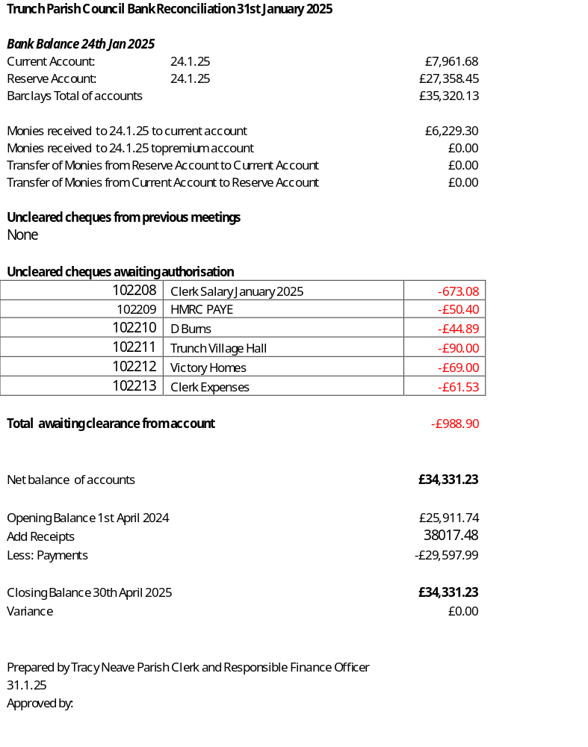

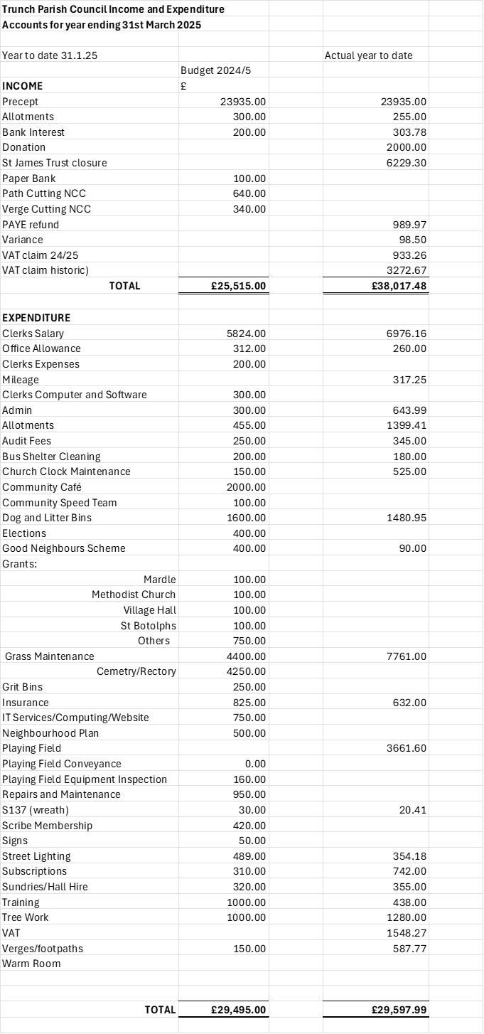
Appendix 3

