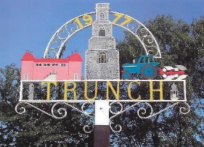

Minutes of Trunch Parish Council Meeting

Held on Tuesday 14th January at 7pm

Present: Cllr. Richard Miles (Chair), Cllrs. Gaynor Houlton, David Burns, Malcolm Bulley Jeremy Fielding, Barbara Wilson, David Houlton, Peter Neatherway, Ed Maxfield, Members of the Public

- Apologies for absence: Cllr Paul Pearson; Parish Clerk Tracy Neave

- Declarations of interest and requests for dispensations
Cllr Wilson: Allotment Holder; Cllr. Miles: Village Hall, allotment holder

- Minutes of previous meeting held on 10th December 2024 were agreed and signed by the Chairperson.

- Public Participation
  - County Councillor’s report: see appendix 1. Cllr Burns requested clarity on how we apply for an extra subsidy to cover the cost of grass cutting as what we are paid by NCC falls far short of the actual cost.
  - District Councillor’s report: Cllr. Neatherway reported that the Local Plan has been pulled back for consideration. Cllr Burns stated that there are ongoing discussions regarding the plan and that clarity is being sought regarding whether infill will be counted towards the total housing allocation for Trunch. Cllr Miles said that what is really needed is affordable housing to encourage a younger demographic to move to the village rather than large executive housing and to discourage holiday and second homes. The provision of driveways for Cornish Avenue is in progress and a bench is being planned for the grass area in Pyghtle Close to discourage the parking of a caravan
  - Public Participation: A member of the public expressed concern about the amount of mole activity on the playing field, saying that it was now affecting the play area, surrounding gardens and into Wades Way and the footpath from the North Walsham Road to Wades Way. He had counted over 400 molehills. He asked why the Parish Council was not arranging for the moles to be killed. It was explained that our policy was not to kill moles but to use humane deterrent methods such as the planting of bulbs (RSPCA recommendation) though this has had limited success. The problem is more acute in winter as during the summer increased activity deters them to a certain extent. Arrangements have been made to have the molehills levelled.

- Correspondence:
  - Unity Trust Banking – TPC is currently with Lloyds but is switching to Unity Trust Bank due to dissatisfaction with their performance. They have lost the deeds to the Village Hall.
- Matters arising from previous minutes
  - Trusteeship MADRAC (Knapton): A number of years ago land was donated at Knapton and put in Trust for use as a football field with both Mundesley and Trunch Parish Councils as trustees. A dispute has now arisen with local residents over the use of land for other purposes, culminating in a visit from a group of residents to the Clerk. The current Parish Council has no interest in the land or the running of the Trust and has decided to resign as trustees to prevent getting embroiled in any future dispute or legal process. Cllr Burns asked whether there were any implications in doing so and Cllr Miles confirmed not. Mundesley PC has already resigned as Trustees.

7. New Items
7.1 Nothing to report

8. Periodic items
8.1 Tender for grass cutting – Invitations to tender have been sent out to three companies. One has declined and we are waiting for responses from the other two.

9. Finance
9.1 Bank statements and bank reconciliation agreed with statements signed by Cllr Miles. See appendix 2
9.2 Income and Expenditure: see appendix 3
9.3 Payment schedule: see appendix ?

9.4 St James Trust – application to close account and transfer money into general reserves submitted.

9.5 Setting the 2025/6 Budget/Precept – This was initially discussed within the Finance Working Group with information disseminated to the Full Council.. There have been certain pressures on the finances beyond our control. Cllr Burns explained that the Clerk’s salary has increased due to increased working hours, the increase in employers NI, government pay increase and backdated pay. Cllr Miles stated that although grass cutting and path maintenance is a large part of our expenditure it is considered necessary in order to maintain the appearance of the village and make it a pleasant environment for the residents. Our reserves are healthy. It was proposed that we remove the cost of the warm room from next years’ budget and take £500 from the reserves to keep the cost of the precept to a minimum. It was also proposed to transfer the money held in St James’ Trust to the Unity Bank to be include in general reserves. The interest earned on this money is likely to exceed that earned within the Trust. The precept of £27,634 was agreed by the Council.

9. Highways
10.1 The diseased tree at Gimmingham Road will be removed in January (NNDC action).
10.2 Priority signage will be installed at Swafield Bridge with the 30mph speed limit extended. Cllrs. Maxwell and Netherfield have had discussions with Victory Housing to resolve parking issues in Cornish Avenue. Outcomes were favourable. Flooding outside of the Social Club is due to blocked drains caused by tree roots. The road would require to be closed and dug up for a permanent fix.
It was proposed that a bench be installed in Cornish Avenue to deter a caravan being parked on the grass.
The unsatisfactory work by County Broadband is being followed up.

11. Playing Field
11.1 To receive any playing field matters and agree actions.
11.2 A working party is to be set up comprising Cllrs. Bulley, Miles, David Houlton and Fielding to agree an action plan to resolve the issues identified in the playing field inspection report.

11. Planning
12.1: Planning Application – nothing to report
13.2 Decisions: PO/24/0716 Land off Bradfield Road, Trunch Construction of 6 self-build
dwellings (outline with details of access only) : refised
12.3 Appeals: The Council was informed that NNDC has written to the Planning Inspector concerning the
application.

13 Footpaths:
13.1 Cllr. Fielding said that NNDC are progressing the issue of the footpath between Trunch and Southrepps

14. To receive a report and consider any actions
14.1 Allotments: Cllr. D Houlton that the allotments are in good condition and the new groundworks are settling down. Wildflower seeds are scheduled to be planted at the Mundesley site in April/May
14.2 Community Speed: Cllr. Miles said that some planned watches had been cancelled due to the weather but that speeding appears to be a diminishing problem possibly due to Speedwatch activity
14.3 Neighbourhood Plan: Cllr. Miles said that approval has been granted to go ahead with the plan and that we will be requesting volunteers from the community to get involved. Outside consultants will also be hired if necessary. The availability of grants is being explored with NNDC.Formal documentation has been sent to NNDC to request authorisation to start the work.
14.4 Good Neighbour Scheme: The scheme continues to be well used with a number of hospital and Doctor’s visits and a regular companionship ‘sitting’ service for a resident in Mundesley.
14.5 Warm Room: This is continuing to be run at Blacksmith’s and has proved popular with a small number of residents.
14.6 Environmental Group: A meeting was held on 11/12/24 and a number of proposals were put forward for potential parish council involvement.
14.7 Snappy Shopper: This continues to be used by a few residents of the village and the surrounding area. Usage has dropped off after Christmas but is picking up. The parish council and Good Neighbours Scheme will support any residents who need assistance with ordering via the App or online.

15. General Parish Issues
Recycling Centre – The booking system for Worstead Recycling Centre is now well established but it has been noted that it is not heavily utilised. Concern was raised about potential closure.
Dog bins – NNDC to make five unannounced visits to check they are being emptied as per contract.

16. Date of next meeting 11th February 2025 7pm at Trunch Village Hall

Public meeting closed at 8.20pm

Appendix 1 County Councillors Report
January 2025

Fly-tipping
A resident contacted me to ask what monitoring was being done to check the impact of recycling centre closures and the new booking system that’s in place. I thought the reply I received was interesting enough to share it more widely so here it is. Doesn’t alter my view that having to book a slot to dispose of waste is a bad idea because it just makes it harder for people to access a public service that could and should be easily available to all:
Fly tipping is a regular concern, shared by many of our residents, that has been raised prior to any service changes that we have made to recycling centres. Our own experience of closing sites (Mayton Wood, Mile Cross and Ketteringham) and reducing operating hours does not reflect that there has been an increase in fly tipping as a result. The vast majority of Norfolk residents do care about our environment and have continued to dispose of their waste responsibly. In January 2023, the Department for Environment, Food and Rural Affairs (DEFRA) carried out a study to find if there were any links between recycling centre booking systems and incidents of fly-tipping and Essex County Council has also published their findings on their website. Neither report found a link, however we will be monitoring all Norfolk data carefully.
We work closely with our colleagues at the district, city and borough councils, on anti-fly tipping campaigns and joint initiatives to prevent and enforce against it. We have been pleased to have the support of both the police and the Environment Agency on delivering our SCRAP fly tipping campaign.
North Norfolk’s Local Plan
Some of you will have been involved in discussions about the revised North Norfolk Local Plan – the document that sets the outline of planning policy decisions across the District. Planning issues are dealt with by the District Council, not the County Council. But the County Council does have a role as a consultee on individual planning issues so I thought I would ask what role the County Council has in relation to the Local Plan. This is the reply I have received to my enquiry. I thought I would share it for your information:
As a Highway Authority we are a consultee in the Local Plan process.
At the local plan stage, we look at the principle of the proposals to understand whether there is a likely highway solution. We provide technical advice throughout the process on a range of sites and highway issues.
Currently we are formulating the technical view on the current North Norfolk consultation and that is prepared by a range of officers, including those involved in considering planning applications.
Defibrillators available at Fire Stations
Defibrillators for use by the public are now available at more than half of Norfolk’s fire stations. Defibrillators give a high energy shock to the heart of people in cardiac arrest and they are available in many public buildings, They were also located at 10 Norfolk fire stations, but this has now been extended to include 22 fire stations in the centre of communities right across Norfolk.
Norfolk fire stations with defibrillators for public use are:
Wroxham, Downham Market, Terrington, Kings Lynn North, Massingham, Wells, Cromer, Mundesley, Carrow, Acle, Swaffham, Watton, Aylsham, Fakenham, Holt, Great Yarmouth, Martham, Wymondham, Earlham, Hunstanton, East Harling and Methwold.
You can find your nearest defibrillator here Defib finder – find the defibrillators nearest you.
Devolution
Just as the BBC likes nothing better than talking about the media, so the County Council loves to talk about Council structures. The Devo Deal is back thanks to the new government – except this time we are being told much more forcefully what’s on offer and to either take it or leave it. In a nutshell, the offer is a directly elected Mayor covering Norfolk and Suffolk in return for extra money and powers and an expectation that we will move to a ‘unitary system’ with the functions of County and District Councils being merged. In place of the two County Councils and 12 District Councils across Norfolk and Suffolk we will likely end up with somewhere between 2 and 5 councils. Lots of people will have spent lots of time over Christmas coming up with plans for the new council boundaries so expect to see lots of discussion of it in the coming weeks. The County Council will hold a special meeting on 9th January to discuss the devolution deal. We should know by the end of January whether it will be taken forward by the Government. This is the briefing I have received:
Deputy Prime Minister Angela Rayner, set out, via a White Paper, the Government’s desire to progress devolution and local government reform. You can read that in detail here if you are interested.
The Government describes what the alternative might be for Norfolk in the absence of our previously agreed County Deal. This would see a Mayor and combined authority covering a larger geography and the mayor would have some additional powers to the previous deal. In addition to this, the White Paper outlines a national approach to structural change that may involve replacing some or all existing district and county councils with new unitary authorities. A Unitary Authority provides all services in their area for example in Leeds or Cornwall. At this stage, no decisions have been made about what will happen in Norfolk.
County council leader Councillor Kay Mason Billig has issued a statement which says: “I agree with the Government that we need to look at the structure of councils and ensure we have a system that delivers the most efficient and effective services that are fit for the future. I am also prepared to support devolution and a Norfolk and Suffolk mayor, if that is the only way to get additional powers and funding to improve lives here. I am keen to engage with the Government and our district councils to consider what the future shape of local government in Norfolk should look like. Let’s put the people before politics and attempt to design something that is the right shape and size to deliver efficient, accountable services to our residents.”
We will now have talks with the Government to better understand the process and timescales. Let me reassure you that this will not be an abrupt change and that a lot of discussion, consultation and planning will be required over the coming months before any changes are introduced. If Norfolk does progress devolution or local government reform, a Mayor will not be in place before 2026 and new authorities will not be created before April 2027 or 2028.
Highways maintenance
Norfolk County Council is to receive £56 million from the government next year to pay for highways maintenance. That’s the biggest increase in the east of England (up by 16 million).
I am sure councillors will be keen to know what Highways plan to spend it on. I will keep you informed!
Wishing you all the best for 2025.
Ed Maxfield
www.edmaxfield.org.uk

Appendix 2 Bank Reconciliation
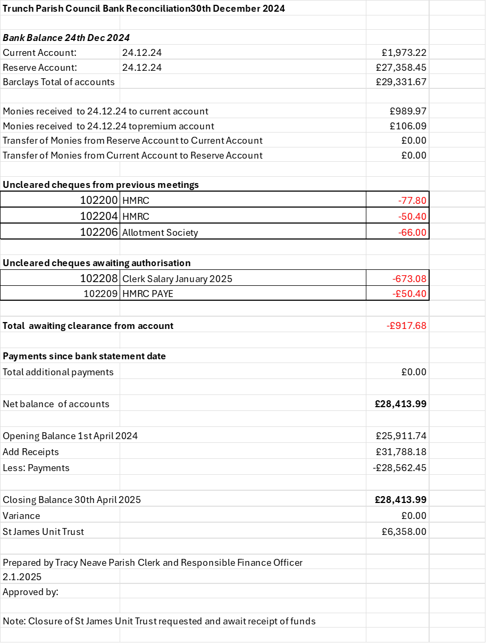

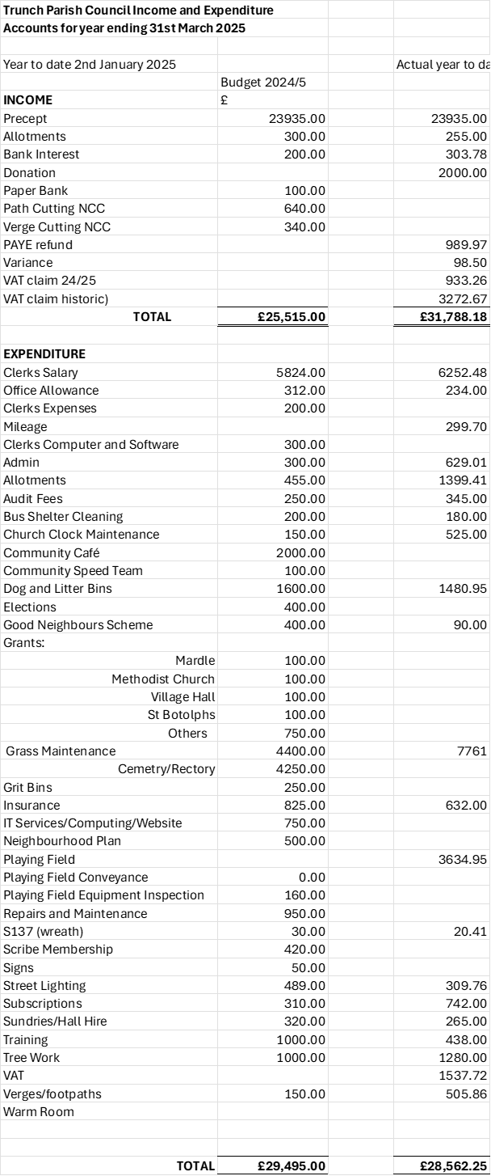
Appendix 3

