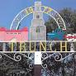
WELCOME TO TRUNCH
Out and about
We are lucky to live close to an Area of Outstanding Natural Beauty, and have a Conservation Area in the village. We are close to the Norfolk Broad’s and the beautiful North Norfolk Coast. Mundesley, Bacton, and Walcott offer easy access to dog friendly beaches (look for seasonal restrictions). In high season there are lifeguards at Mundesley and you can rent a beach hut which might be handy for visiting friends and relatives!
The village is surrounded by quiet country lanes, and benefits from a number of different walks – see https://www.trunch-norfolk.co.uk/visiting/walks/ for some ideas.
Transport – we have a good bus service with buses running to North Walsham, Norwich, Wroxham and Cromer and a coastal village bus. Timetables and routes are shown at bus stops around the village, or at https://bustimes.org/localities/trunch. The nearest train stations are Gunton and North Walsham. If you need community transport for hospital visits etc they can be contacted on 01692 500840. Our village has its own ‘Good Neighbours Scheme who also give lifts to doctors and hospitals and do some basic DIY and their number is 07749 010349.
Health - The nearest hospital is at Cromer (Mill Road, Cromer, NR27 0BQ) – there is a minor injuries unit which is open seven days a week, from 8am to 7.45 pm (Tel: 01603 646230). There are no doctors in the unit, so it is best to telephone to find out if the Minor Injuries Unit is the best place, if you need help.
There are GP surgeries in Mundesley (Mundesley Medical Centre) and North Walsham (Birchwood Medical Practice and Paston Surgery. Contact details are available on line.
Where to find out more:
We have a monthly newsletter – the Trunch Mardle – that is delivered to all residences in the village. The Mardle is an excellent way of finding out what’s happening in the village.
Next Door is a local neighbourhood network, where you can share or view information, and connect with people in your area. https://nextdoor.co.uk/.
Trunch Village Web Site: Here you can find the history and much more about the activities and groups: https://trunch-norfolk.co.uk/

Welcome to the village! From Trunch Parish Council!
Welcome to Trunch! We hope you are settling in and enjoying your new home. We have a strong and vibrant community, which we hope you will soon become part of.
Our ‘Vision’ for our village is ‘Good Living, Great Community’, and we work hard to those ends. We have shared some information in this welcome pack which we hope will be of interest.
The Parish Council deals with local services and issues at a practical and detailed level. We have a responsibility to community safety and managing village amenities (playing field, allotments etc). We represent the views of the local community regarding planning applications and other proposals that affect the parish and its residents.
As a Parish Council we have ambitious plans to build on what is already a great place to live, and our 10-year vision for Trunch we hope will make it even better, including becoming a more vibrant, self-supporting and sustainable community, with services and products locally sourced and provided, as much as possible. There are opportunities to be part of that and more – we are always looking for ideas, volunteers and feedback.
We meet every second Tuesday of the month – dates and times are displayed on the Parish Council notice board opposite the Church and our website (www.trunch-pc.gov.uk) – and we welcome members of the public to our meetings.
You can contact Parish Councillors, or the Parish Clerk, if you want any information or have anything you want to discuss. clerk@trunch-pc.gov.uk 

- Litter picking
- Community composting
- Bee keeping
- Trunch activity - events like yard sales, party in the paddock, dog shows, scarecrow and open gardens
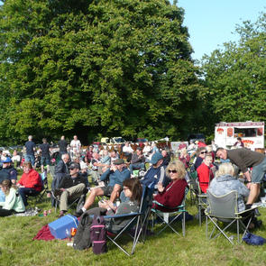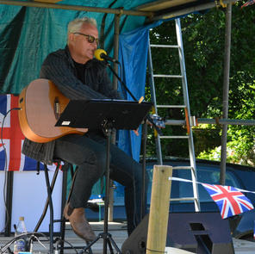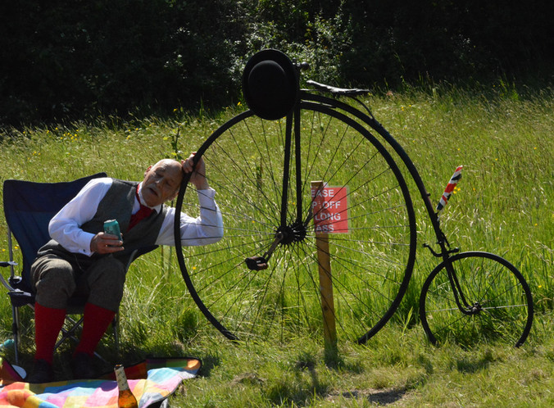
Volunteers are always welcome – this presents a really good opportunity to get involved in your new community. Details of the Trunch Village Society can be found at https://www.trunch-norfolk.co.uk/regular-events/, as well as on the TVS notice board which is situated on the Gimmingham Road.
Re-cycling – We clothes recycling bin by the entrance to the playing field in Blooms Turn.
Shopping
Some of the nearest shops are:
- Southrepps – post office and convenience store.
- Swafield – Tasty Tavern butcher and farm shop
- Mundesley – Tesco express and a convenience store, post office, butcher, greengrocer, pharmacy and clothes shop.
- North Walsham – a wider range of shops including chemists, food shopping, a weekly market, butchers, bakery etc. There is a Waitrose and a Sainsbury for larger shops, with a petrol station at Sainsbury’s.
Mobile library – there is a mobile library service that visits the village every month. For enquiries, telephone 01603 222303.

A little bit about the neighbourhood…
For a small rural village (around 900 people at the last Census), we have a lot going on! From the Trunch Garden Society, French Conversation, sports and fitness activities, arts and crafts and a book club to social events and opportunities – here are just some…
St Botolph’s Church sits at the heart of the village, dating back to the early 15th century. A Benefice Holy Communion Service is held every second Sunday (see https://trunchgroup.org/whats-on/ for more detail) and the church is open daily.
St Botolph’s is also used to host cinema nights, music, ensembles, and theatre productions (see https://trunchconcerts.com/st-botolphs/). The church porch usually displays information about local activities.
Next to the church, we have The Crown at Trunch – The pub has regular events (music, groups, quiz night etc) which are promoted outside the pub and on the website. http://www.thecrownattrunch.co.uk/).
Trunch Social Club (on Gimmingham Road) is open every day and offers two beer festivals a year. It is a membership club, with temporary membership and full membership options available (tel:+441263720463). The Club hosts regular activities (quiz nights, member’s draw, bingo) and live music.
The Methodist Church sits on the North Walsham Road, offering services every Sunday and open daily. There is a coffee morning each month, with all welcome.
Trunch Village Hall is a gem in the community. It offers regular social activities (coffee mornings, and a lunch club each month) with a host of other activities (including games afternoons, murder mystery, pamper evenings, knitters and stitchers, fitness classes to name but a few – see https://www.trunch-norfolk.co.uk/regular-events/ or the notice board outside the hall, for more details). The Village Hall is a great place to meet neighbours in an informal, relaxed environment.
Trunch Village Society
The Trunch Village Society (TVS) was created to raise funds for village groups and projects. TVS organises village events to help fund project groups, profit from which help to grant awards to village organisations and groups. There are four project groups:

